**Unveiling Market Insights: Analysing Spending Behaviour and Identifying Opportunities for Growth**

**1.Introduction:**

* 1. **Overview:**

The project "Unveiling Market Insights" aims to conduct a comprehensive analysis of consumer spending behavior within a specific industry or market segment. By leveraging data analytics and market research, the project seeks to identify trends, patterns, and opportunities for growth. The ultimate goal is to provide actionable insights that can help businesses make informed decisions and optimize their strategies to capitalize on emerging opportunities in the market.

* 1. **Purpose:**

The purpose of the project "Unveiling Market Insights" is to delve into consumer spending behavior, meticulously analyze market trends, and leverage this data to identify untapped growth opportunities. This initiative aims to empower businesses with valuable insights to make informed decisions and stay ahead in a dynamic marketplace.

**2. Problem Definition & Design Thinking:**

**2.1 Empathy Map:**

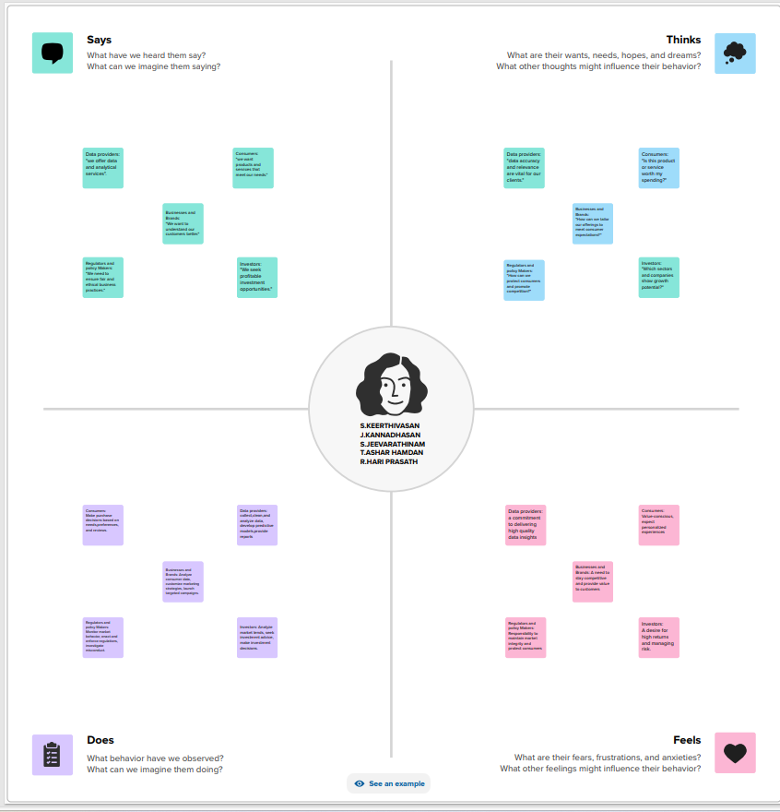

**2.2 Ideation & Brainstorming Map:**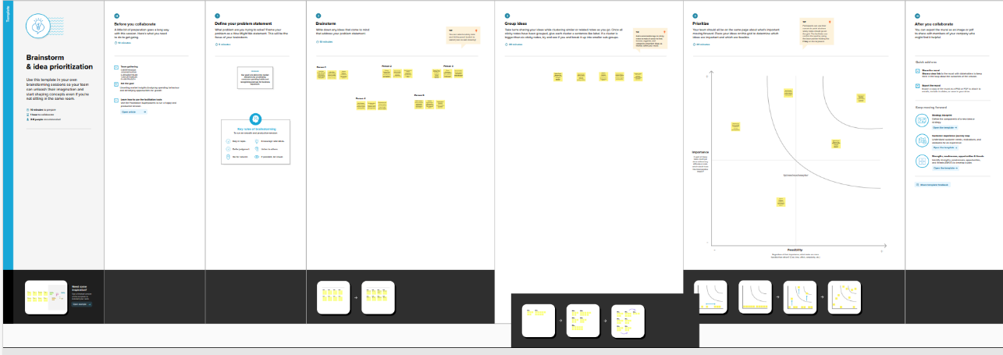

**3.Result:**

**KPI (Milk):**

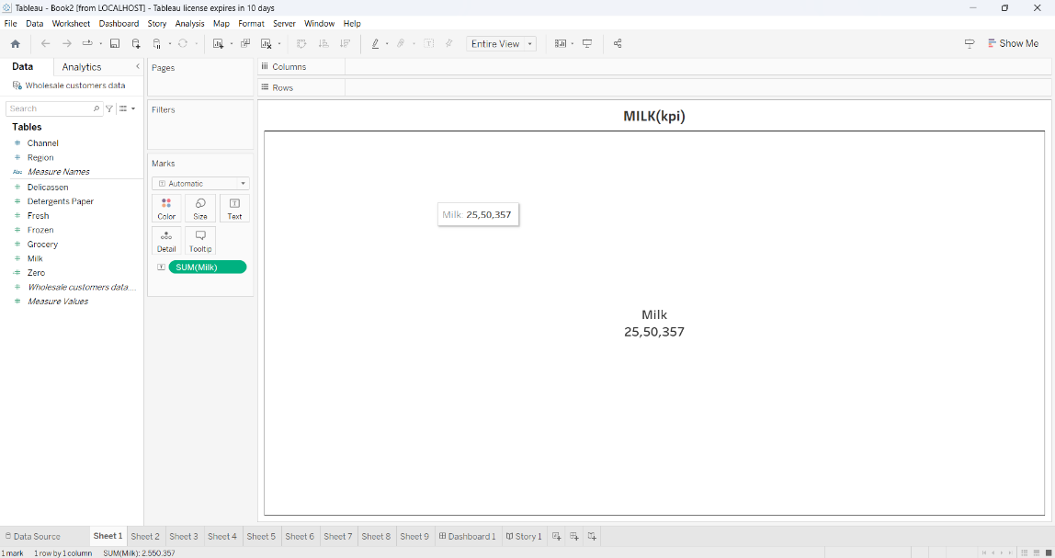

**KPI(Fresh):**

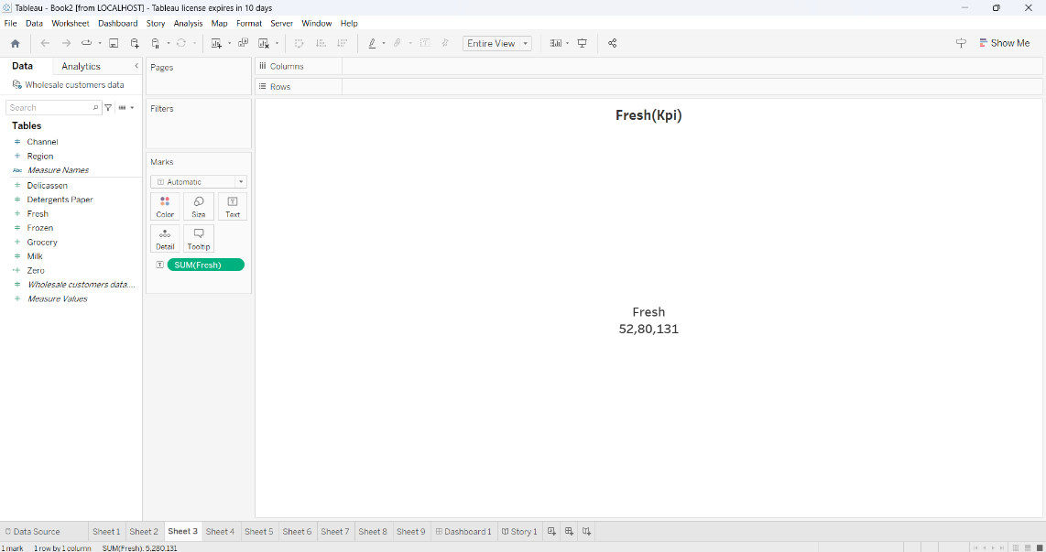

**KPI(Grocery):**

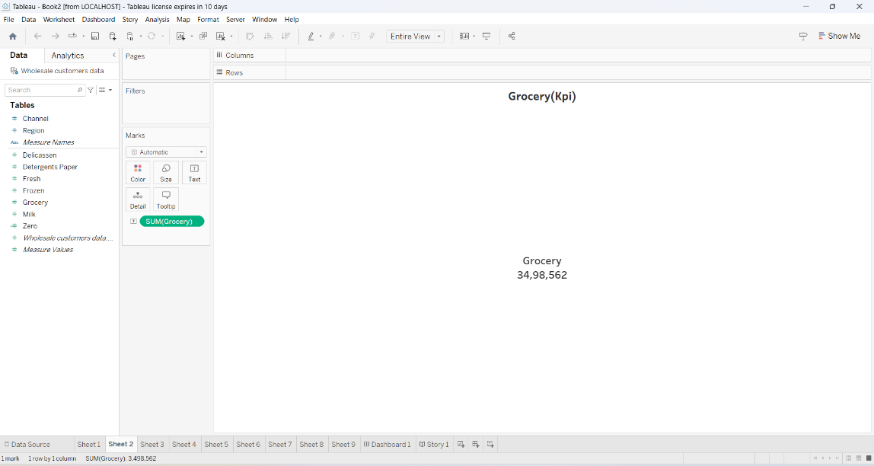

**Area And Polygon Region:**

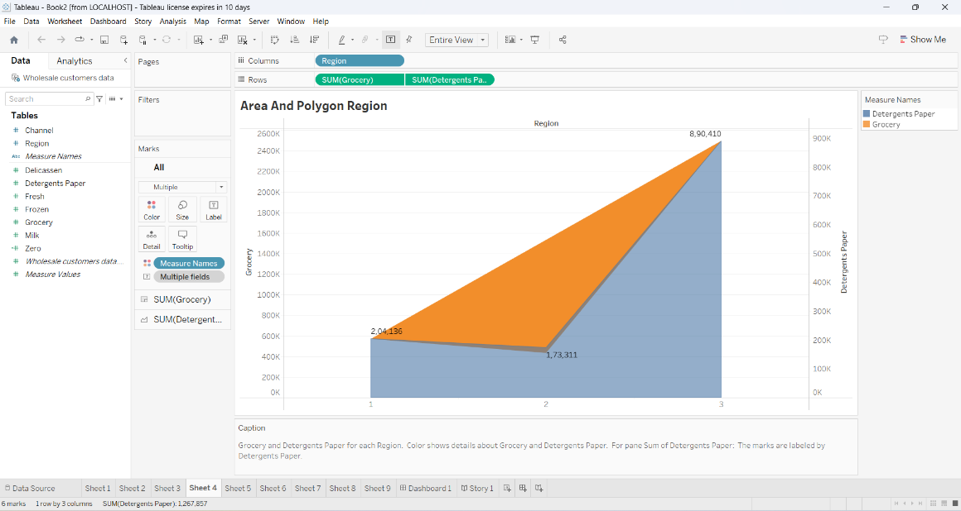

**Arrow Chart:**

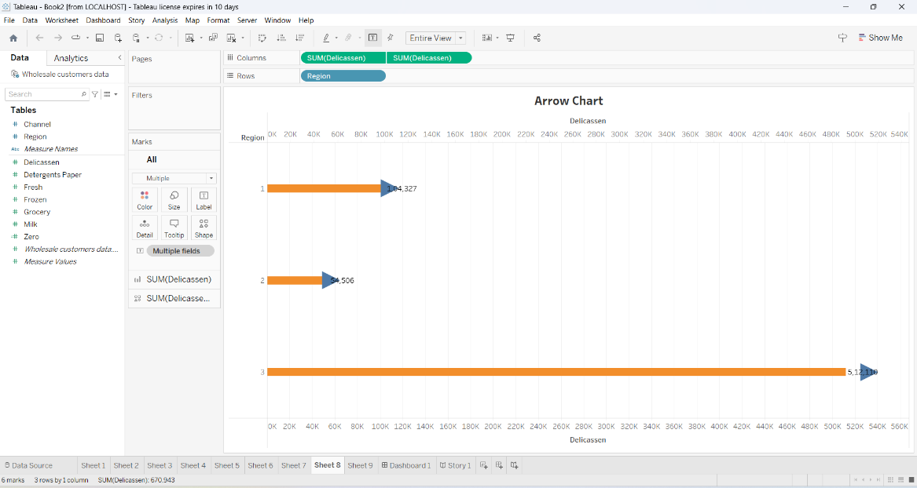

**Bar And Area:**

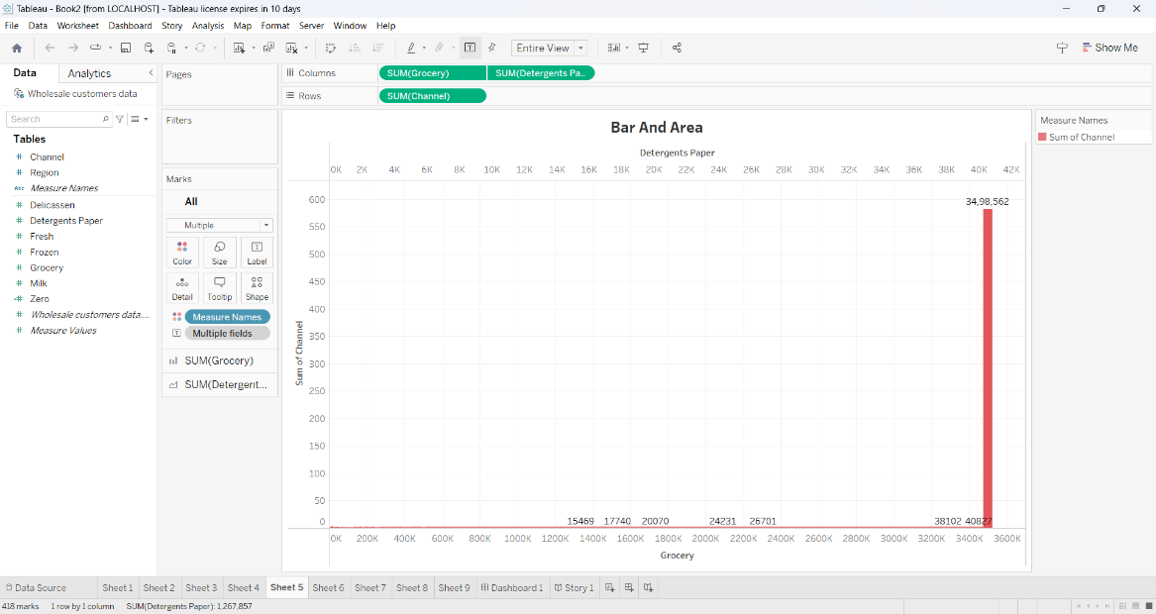

**Butterfly Chart:**

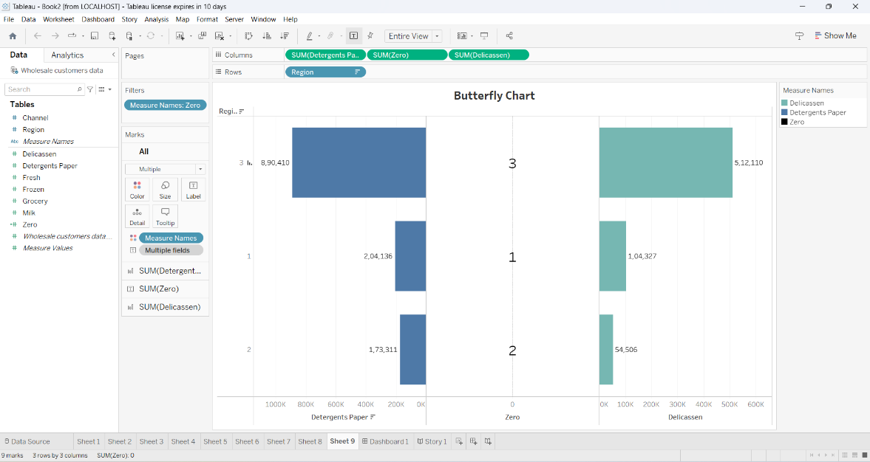

**Lollipop Chart**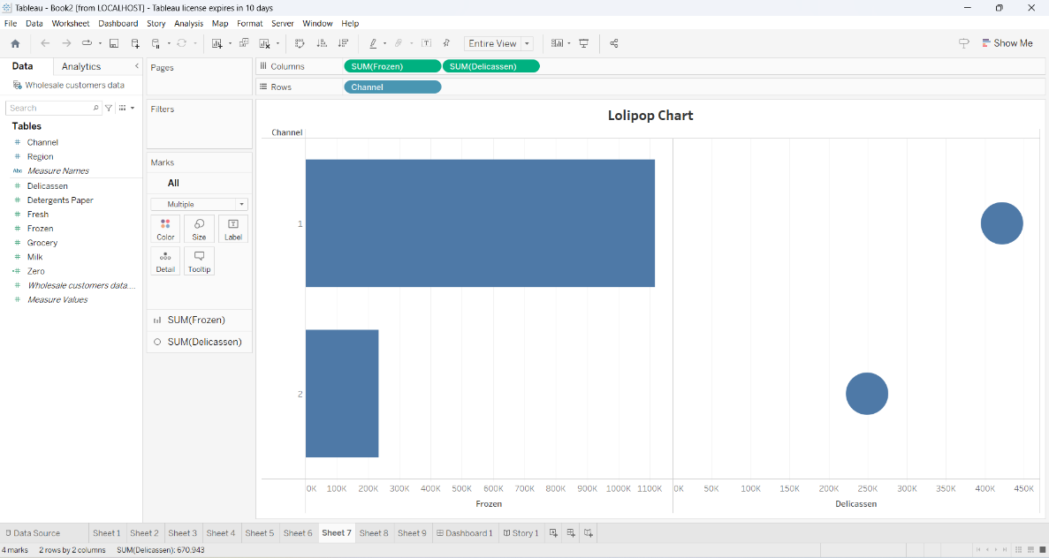

**Pie Chart:**

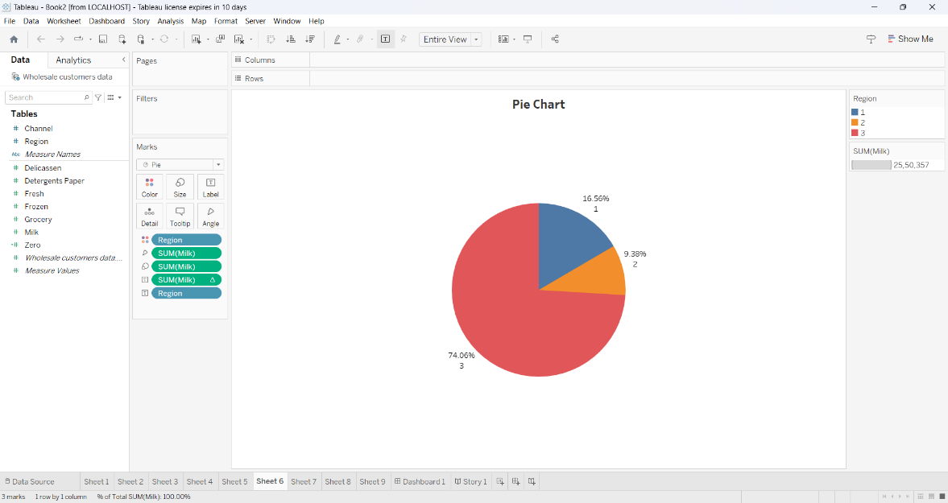

**Wholesaler Customer Analysis:**

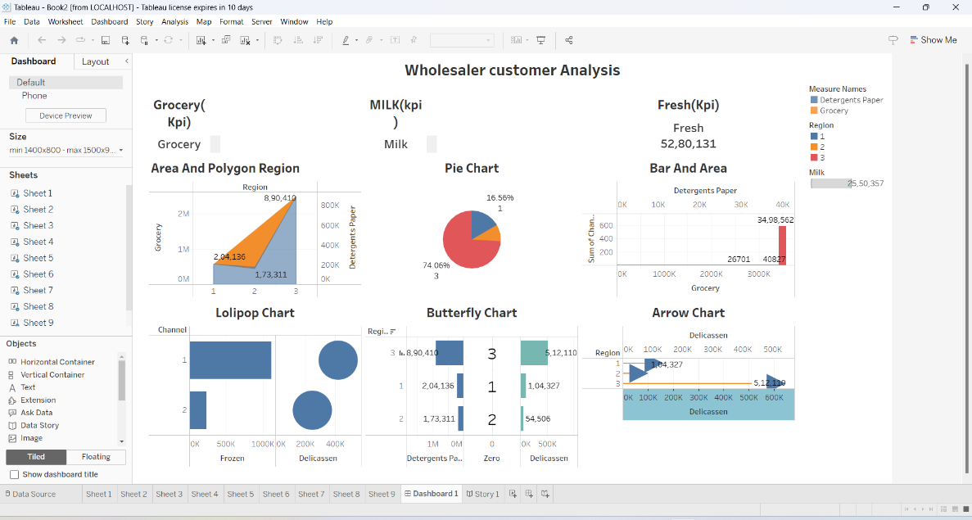

**Story (Milk KPI):**

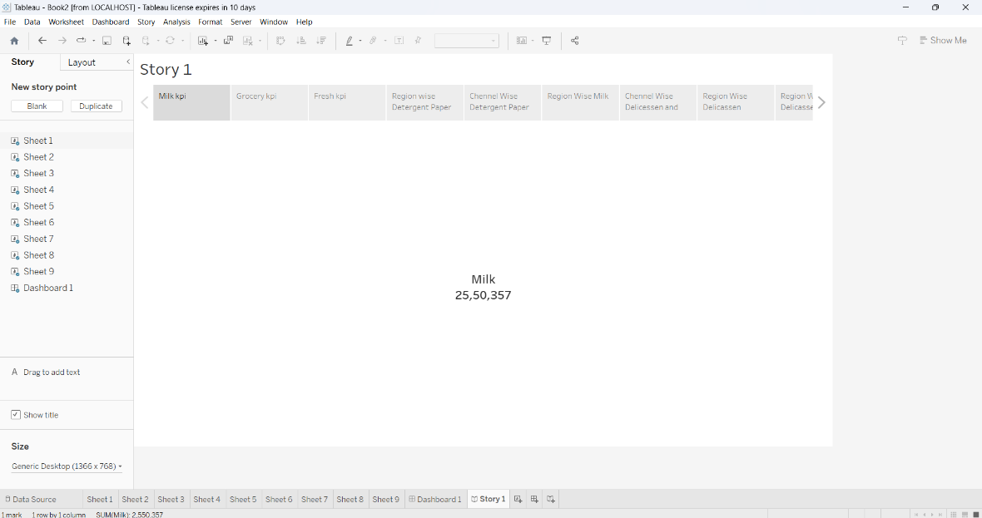

**Story (Fresh KPI):**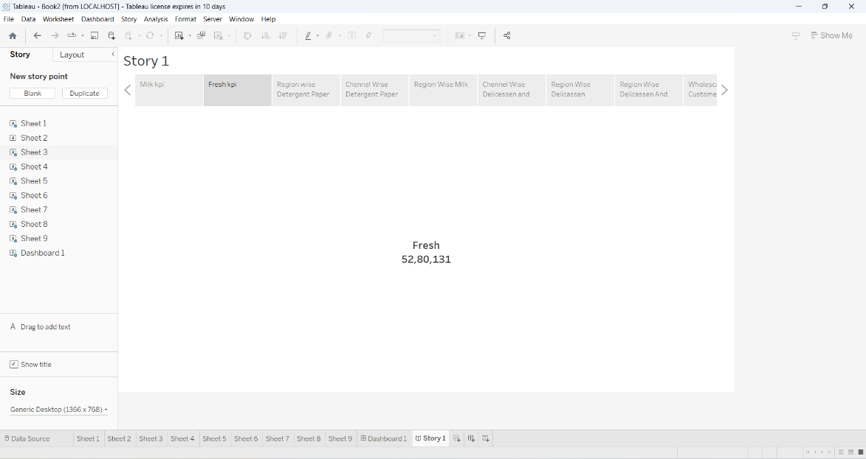

**Story (Grocery KPI):**

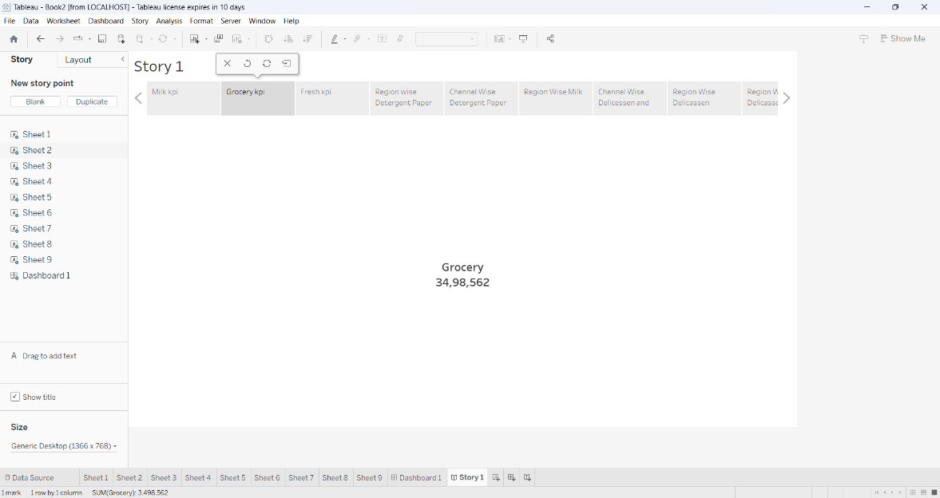

**Story (Area And Polygon Region):**

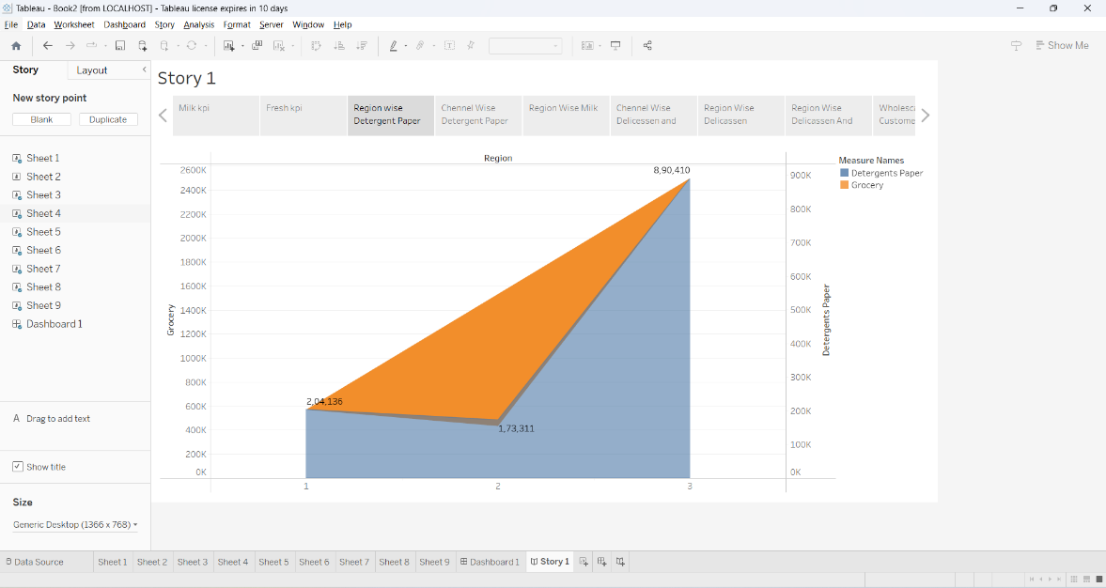

**Story (Arrow Chart):**

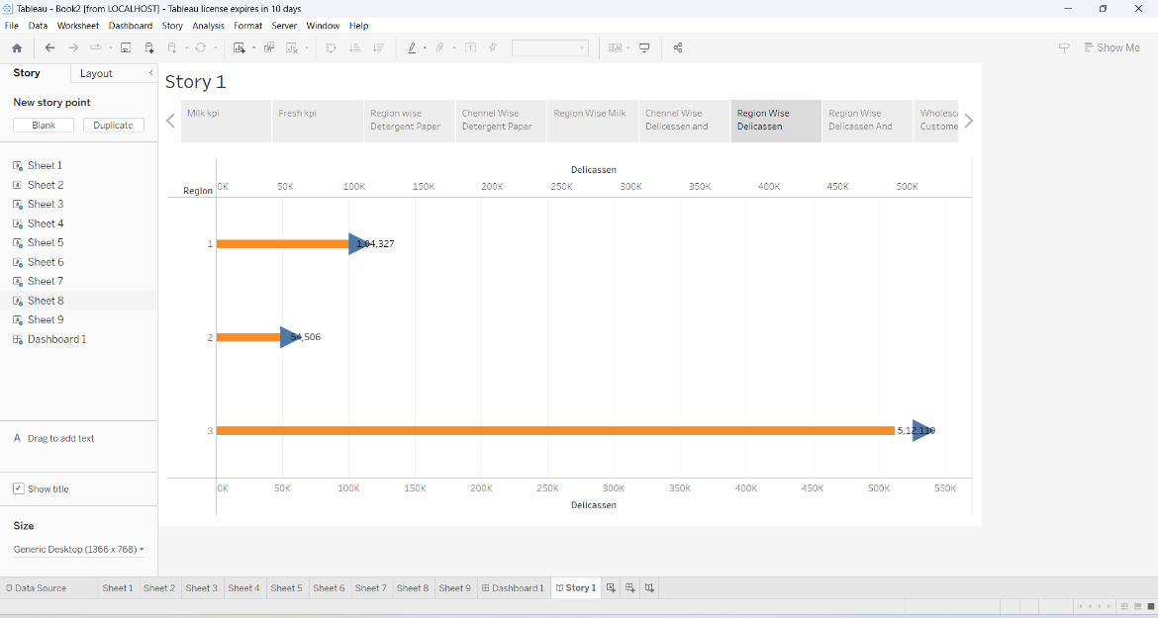

**Story (Bar And Area):**

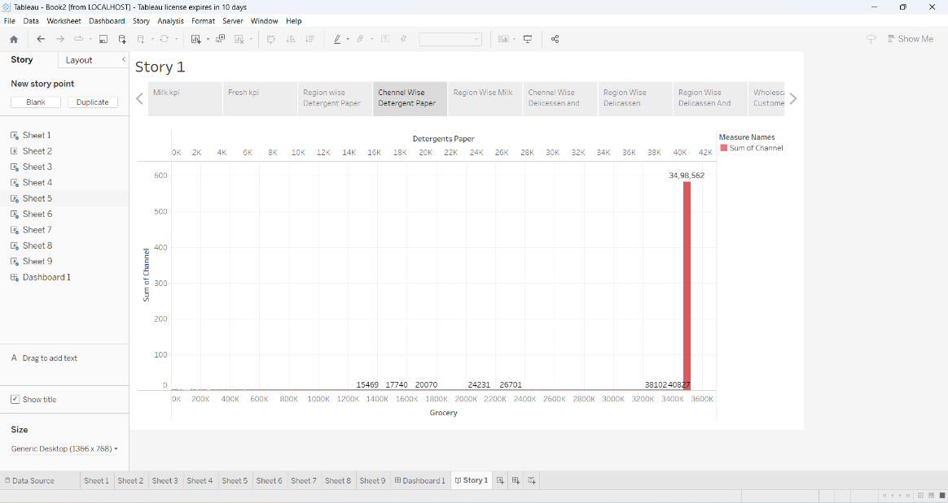

**Story (Butterfly Chart):**

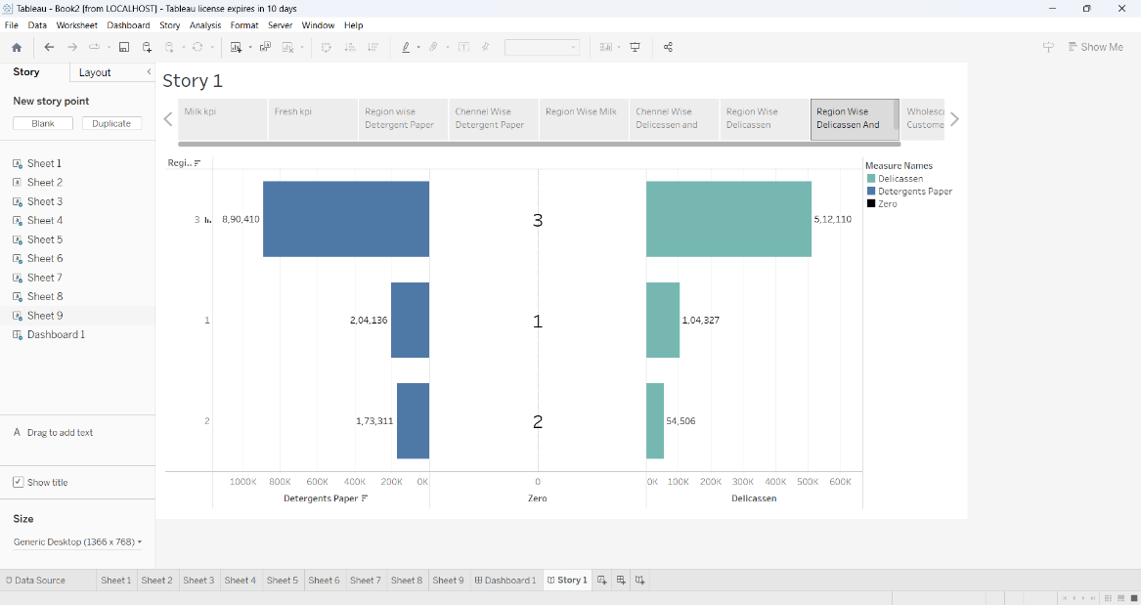

**Story (Lollipop Chart):**

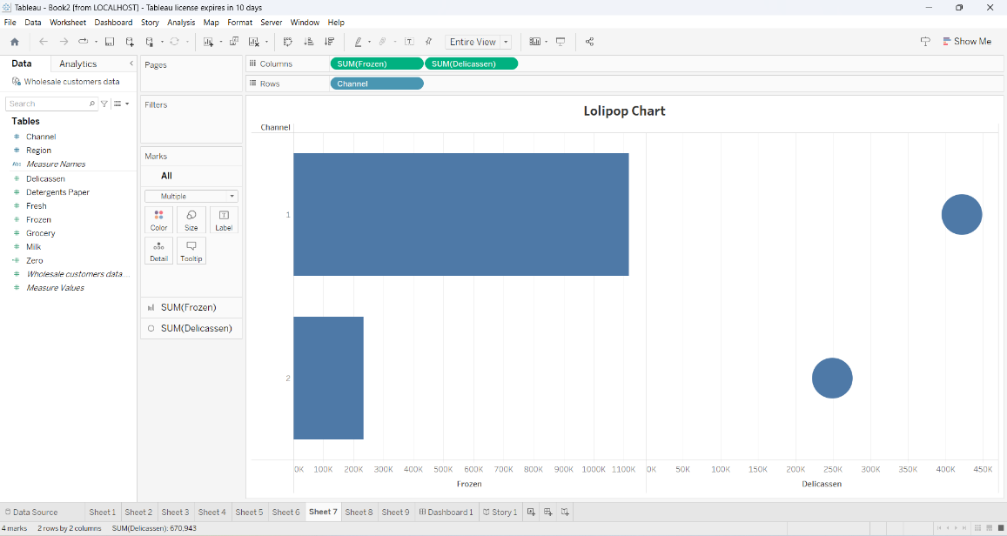

**Story (Pie Chart):**

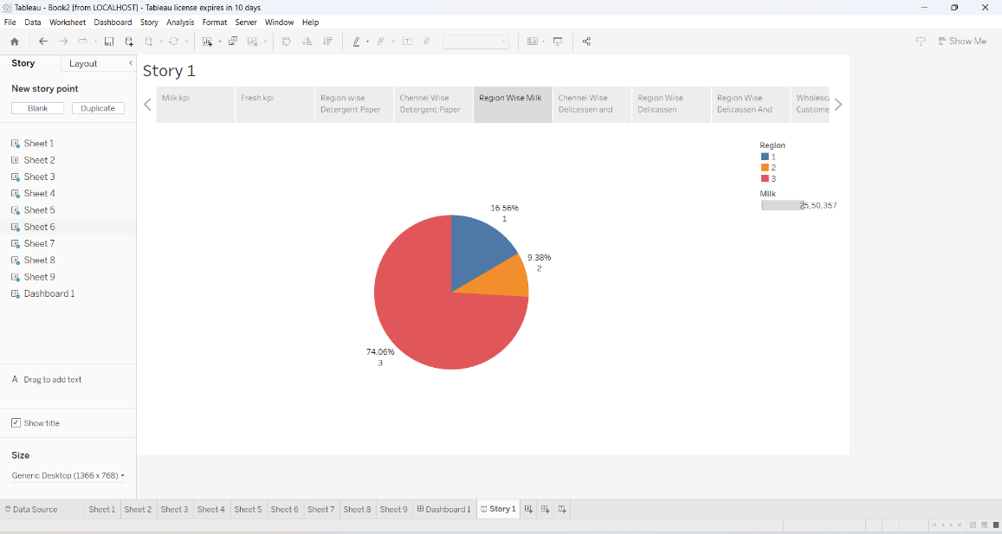

**4.Advantages and Disadvantages:**

**Advantages:**

*Identifying Growth Opportunities: It enables the identification of untapped market segments and areas for potential growth, allowing for strategic expansion.

*Competitive Edge: Access to market insights can give a competitive edge by staying ahead of trends and consumer preferences.

**Disadvantages:**

*Data Collection Challenges: Gathering and analyzing spending behavior data can be costly and time-consuming, and there may be limitations in data availability.

*Changing Market Dynamics: Markets are dynamic, and insights may quickly become outdated, making it essential to continuously update analyses.

**5.Applications:**

Unveiling Market Insights aims to provide a comprehensive analysis of consumer spending behavior within a specific market segment. By leveraging data analytics and market research techniques, it seeks to uncover valuable insights that can help businesses identify untapped growth opportunities. This project will offer actionable recommendations to businesses, enabling them to make informed decisions and refine their strategies to maximize profitability and market share.

**6.Conclusion:**

The project "Unveiling Market Insights: Analyzing Spending Behavior and Identifying Opportunities for Growth" has shed light on critical consumer trends and spending patterns. Through rigorous analysis, we have identified untapped opportunities for business growth, enabling companies to make data-driven decisions and adapt to the ever-evolving market landscape. This project serves as a valuable resource for strategic planning and market expansion.

**7.Future scope:**

Unveiling Market Insights: Analyzing Spending Behavior and Identifying Opportunities for Growth" involves leveraging advanced data analytics and artificial intelligence to gain deeper consumer insights. This includes predictive analytics for personalized marketing, exploring emerging markets, and optimizing supply chains for sustainable growth. Additionally, the project can expand to incorporate real-time data sources and predictive modeling for staying ahead in the rapidly evolving market landscape.